Mountain View

Community Hospital

DBMS Report

April 12, 2016

Author: Matthew Cormier, Gurpreet Singh Maan,

Maitri Gemlawala

**Table of Contents**

Page #

1. Title Page i
2. Table of Contents ii
3. Introductory Memo 3
4. Mission Statement 4
   1. Mission Objectives 4
5. System Diagrams 5-7
   1. System Boundary 5
   2. User Views 6
   3. Use Case 7
6. Normalization 8-10
   1. 3rd Normal Form 8
   2. Functional Dependencies 9-10

7. Data Dictionary 10-12

9. Appendix 13-18

* 1. Appendix A 13-16
  2. Appendix B 17-18

**Introduction**

To: Mountain View Management team

From: Matthew Cormier, Project Manager

Date: April 12, 2016

Re: DBMS system report

Dear Mountain View Community Hospital Management,

We would like to update you on our progress in analyzing and designing a database solution for the hospital. After reading the provided system documentation and reviewing interview questions with your staff, a relational model database management system should be implemented under the standard Database Life Cycle. The central business problem of the current system is the restriction of batch processing, which only permits static time based queries such as weekly cost reports.

To solve this, the new system will completely replace the current system but will provide all previous functionality while providing the support to record lab tests and procedures, tracking costs for each centre/department, and online processing. Also, the new system will allow for much more flexibility for future change or growth in the business. Data will be able to be recorded and retrieved instantly by staff while also generating time based reports.

This report will further expand on the design of the new database system. Finally, a mock prototype will be presented to demonstrate the report functionality.

**Mission Statement**

This new proposed system for MVCH will replicate the operations of the previous system while expanding the capabilities to allow instant custom data entry and retrieval, management of specific resources, the creation of flexible reports, and room for future scalability.

**Mission Objectives**

To maintain (enter, update, and delete) data on Patients

To maintain (enter, update, and delete) data on Physicians

To maintain (enter, update, and delete) data on Patient Billing

To maintain (enter, update, and delete) data on Hospital Rooms

To maintain (enter, update, and delete) data on Staff

To perform searches on Patient Billing

To perform searches on Hospital Rooms

To perform searches on Physician Referrals

To track the status of Hospital Rooms

To track the status of Patients

To track the status of Department/Cost-Centre costs

To report on Daily Revenue

To report on Room Utilization

To report on Patient Billing

To report on Revenue Analysis

To report on Physician Referrals

**System boundary**

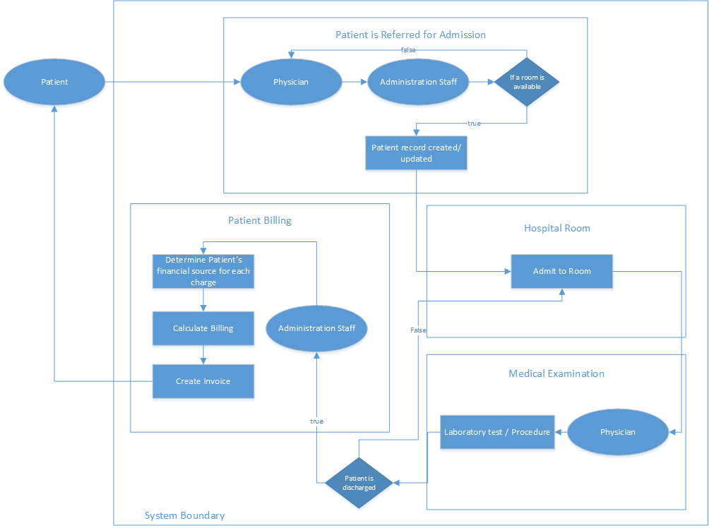

This system boundary diagram depicts the process of a standard patient being referred for admission within the hospital. This process includes being referred, having a record created/updated, being admitted to a room, medical producers, and the billing steps before discharge. The process in linear through the flow of steps the patient is involved with.

The process begins with the patient requesting/meeting with a physician who may refer them for admission. Once referred, administration staff check for an available room. If there is no available space, the patient is sent back to the physician for referral elsewhere. If there is available room, a patient record is created/updated with current patient information. The patient is then admitted along with the creation of an admission record.

At a later period, a physician will exam the patient or provide medical procedures. These procedures will be recorded. Once the physician has deemed the patient ready for discharge from the hospital, the patient is sent back to the administration staff. A bill/invoice of the stay will be created and sent to the patient once discharged. Financial sourcing for each charge will be determined at the time of bill/invoice creation by the administration staffer.

**User view**

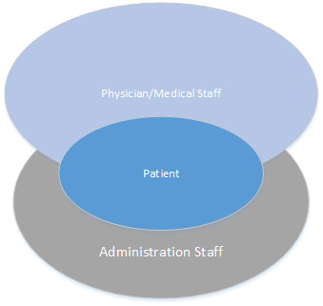

Patient will only have access to their patient record and any sent bills/invoices for their previous admissions to the hospital. Physicians and other appropriate medical staff will have access to medical procedures and partial access to patient records. Medical staff should not be able to access patient billing or business revenue information. Administration staff will have access to patient records excluding confidential medical information, billing, business revenue information, and room availability. Neither staff type should have access to each other’s records. These restrictions will decrease staff from reviewing unrelated information to their fields and will also increase the medical/financial information of the patients.

**Use Case Diagrams**

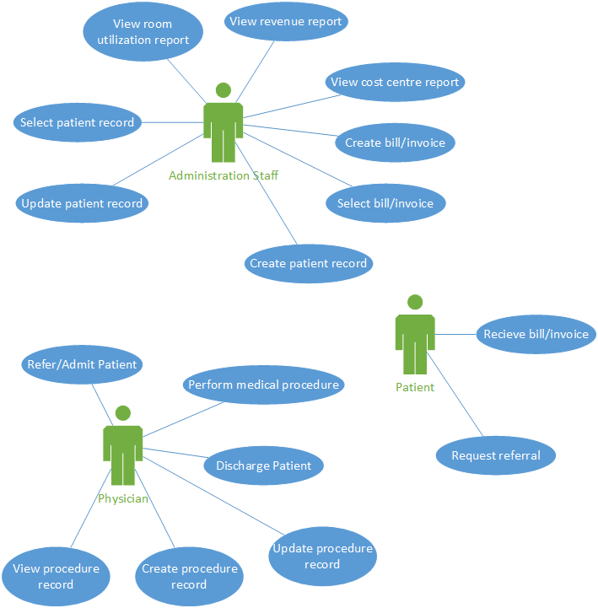

These diagrams depict the processes that each of the three actors, physician, administrator, and patient, can perform within the system. Patients can request referral/appointments with the physicians and can receive billing information in regards to their admission charges. Physicians can refer and discharge patients. They can also create and view medical procedure records. Finally, administrators can create/view billing invoices, create/view revenue/cost centre reports, and can create/update patient records. Administration staff can also archive patient records.

**Normalization**

Below is the data of the system normalized to a 3rd normal form within tables. This 3NF data maintains functional dependency while having eliminated repeating/redundant records, partial dependencies, and transitive dependencies.

**3rd Normal Form**

PATIENTS PATIENT_ID, PATIENT_NAME, PATIENT_ADDRESS, PATIENT_CITY, PATIENT_PROV, PATIENT_POSTAL_CODE, PATIENT_PHONE_NUMBER, GENDER, HCN, FINANCIAL_STATUS

LOCATION_ADMITTED PATIENT_ID, LOCATION_ID, DATE_ADMITTED, BILL_ID, DISCHARGE_DATE

PHYSICIANS PHYSICIAN_ID, PHYSICIAN_NAME, PHYSICIAN_PHONE_NUMBER, SPECIALTY

PATIENTS_REFERRED PHYSICAN_ID, PATIENT_ID,

ROOMS LOCATION_ID, ROOM_TYPE, EXTENSION

PATIENT_BILLS BILL_ID, BILL_DATE, BALANCE_DUE

SERVICES_CHARGED BILL_ID, ITEM_ID, DATE_CHARGED, QUANTITY, FINANCIAL_SOURCE

ITEMS ITEM_ID, COST_CENTRE_ID, ITEM_DESCRIPTION, ITEM_CHARGE

COST_CENTRE COST_CENTRE_ID, COST_CENTRE_NAME

|  |  |  |
| --- | --- | --- |
| **Functional dependences** | | |
| Determinant | Dependency | Dependent Attribute |
| Patient ID |  | Patient Name |
| Patient ID |  | Patient Address |
| Patient ID |  | Patient City |
| Patient ID |  | Patient Province |
| Patient ID |  | Patient Postal Code |
| Patient ID |  | Patient Phone Number |
| Patient ID |  | Gender |
| Patient ID |  | HCN |
| Patient ID |  | Financial Status |
| Patient ID, Location ID, Date Admitted |  | Discharge Date |
| Patient ID, Location ID, Date Admitted |  | Bill ID |
| Location ID |  | Extension |
| Location ID |  | Room Type |
| Physician ID |  | Physician Name |
| Physician ID |  | Physician Phone Number |
| Physician ID |  | Specialty |
| Bill ID |  | Bill Date |
| Bill ID |  | Balance Due |
| Bill ID, Item ID, Date Charged |  | Quantity |
| Bill ID, Item ID, Date Charged |  | Financial Source |
| Item ID |  | Cost Centre ID |
| Item ID |  | Item Description |
| Item ID |  | Charge Price |
| Cost Centre ID |  | Cost Centre Name |

**Data Dictionary**

This data dictionary organizes the data into tables with columns. This format will be similar to the finalized database tables.

|  |  |  |  |  |
| --- | --- | --- | --- | --- |
| **Table Name** | **Column Name** | **Description** | **Data Type** | **Key?** |
| **Patients** | Patient ID | Identifier for the patient. This domain will hold records for patients admitted to the hospital. | Char | Primary |
|  | Patient Name | Given name of the patient. | Varchar |  |
|  | Patient Address | Patient’s street address. | Varchar |  |
|  | Patient City | Patient’s city address. | Varchar |  |
|  | Patient Province | Patient’s province address. | Varchar |  |
|  | Patient Postal Code | Patient’s postal code. | Varchar |  |
|  | Patient Phone Number | Patient’s phone number. | Varchar |  |
|  | Gender | Patient’s gender. | Varchar |  |
|  | HCN |  | Varchar |  |
|  | Financial Status | Patient’s secondary financial source of health coverage. | Char |  |
| **Location Admitted** | Patient ID | Identifier for the patient. This domain will act as a joint table between patients and locations they are/were admitted to. This will allow patients to have records for multiple admissions. | Char | Primary |
|  | Location ID | Identifier of a room. | Char | Primary |
|  | Date Admitted | Date of the admission. | Date | Primary |
|  | Bill ID | Key for the bill for the admissions. | Char | Foreign |
|  | Discharge Date | Date of the patient’s discharge. | Date |  |
| **Physicians** | Physician ID | Identifier of a physician. This domain holds records for referring physicians. | Char | Primary |
|  | Physician Name | Physician’s name. | Varchar |  |
|  | Physician Phone Number | Physician’s phone number. | Varchar |  |
|  | Specialty | Physician’s practiced field. | Varchar |  |
| **Patients Referred** | Physician ID | Identifier of a physician. This domain will be a joint table linking physicians to their referred patients. | Char | Primary |
|  | Patient ID | Identifier for the patient. | Char | Primary |
| **Rooms** | Location ID | Identifier of a room location. This domain holds records for room locations in the hospital. | Char | Primary |
|  | Room Type | Type of room (private, semi-private, etc.). | Varchar |  |
|  | Extension | Phone extension for the room. | Char |  |
| **Patient Bills** | Bill ID | Identifier of the patient bill. This domain holds records of bills/invoices for patient admissions. | Char | Primary |
|  | Bill Date | Date of the bill being issued. | Date |  |
|  | Balance Due | Total due to be paid by the customer. | Decimal |  |
| **Services Charged** | Bill ID | Identifier of the patient bill. This domain will be a joint table allowing multiple items and items of the same type to be billed together as necessary. | Char | Primary |
|  | Item ID | Identifier of an item. | Char | Primary |
|  | Date Charged | Date of the item charged. | Date | Primary |
|  | Quantity | Number of the item being charged. | Integer |  |
|  | Financial Source | The staff member who creates the record determines the financial source that the patient will be charged by. | Varchar |  |
| **Items** | Item ID | Identifier of an item. | Char | Primary |
|  | Cost Centre ID | Identifier of the cost centre the item falls under. | Char | Foreign |
|  | Item Description | Description of the item. | Varchar |  |
|  | Item Charge | Unit price of the item. | Decimal |  |
| **Cost Centre** | Cost Centre ID | Identifier of a cost centre within the hospital business. | Char | Primary |
|  | Cost Centre Name | Name of the cost centre. | Varchar |  |

**Appendix A**

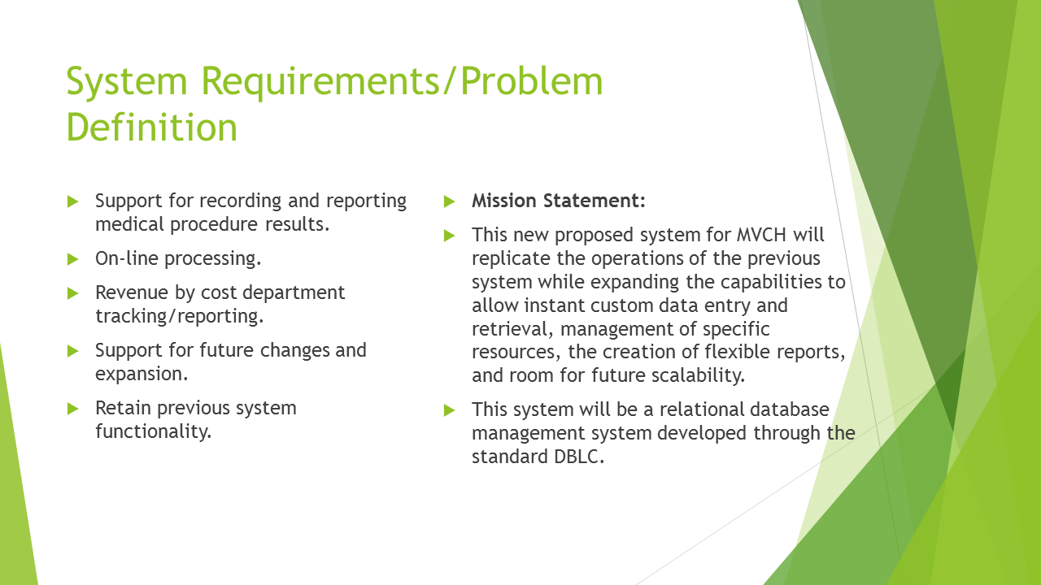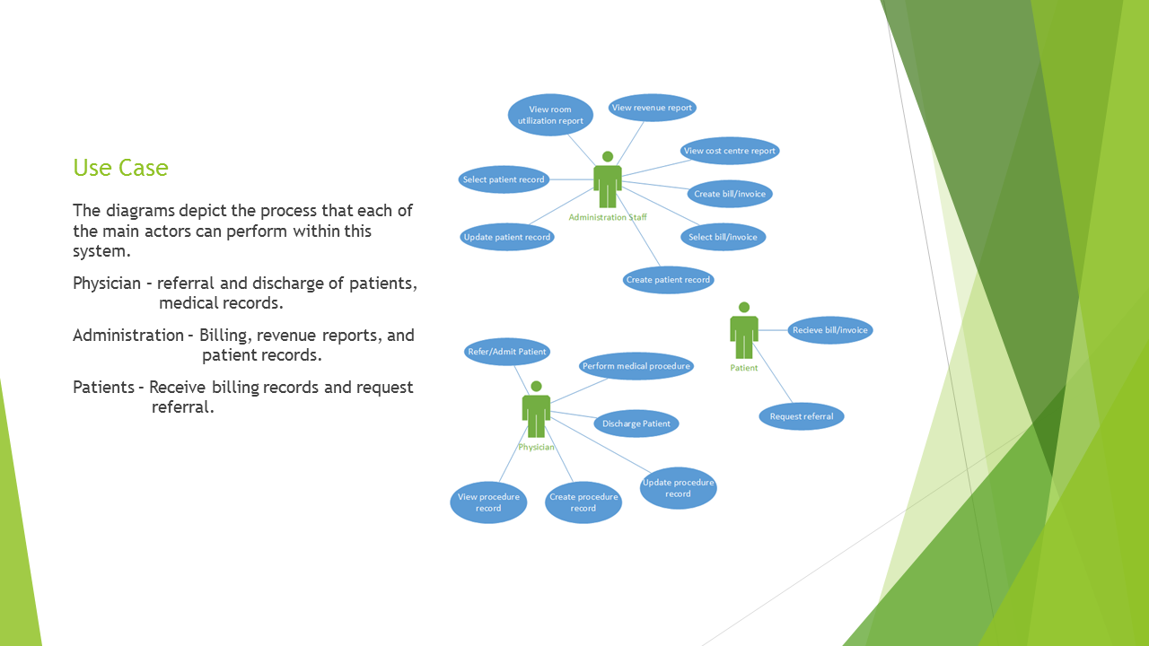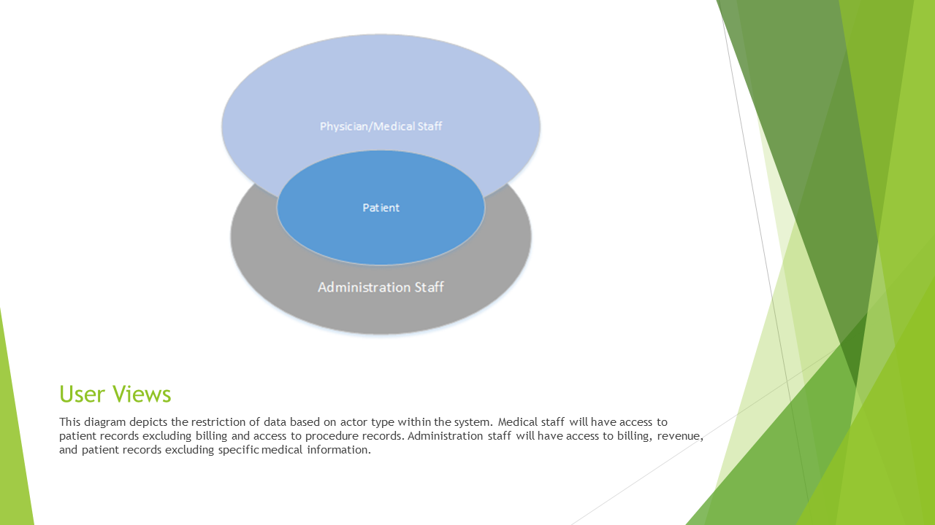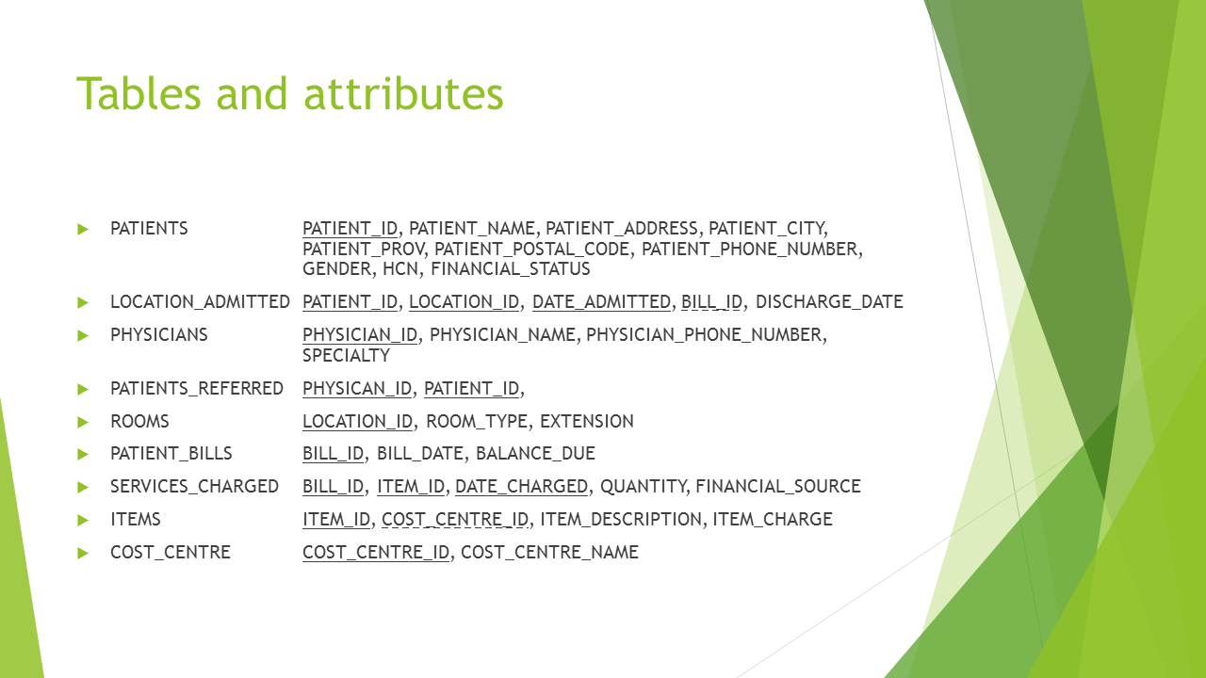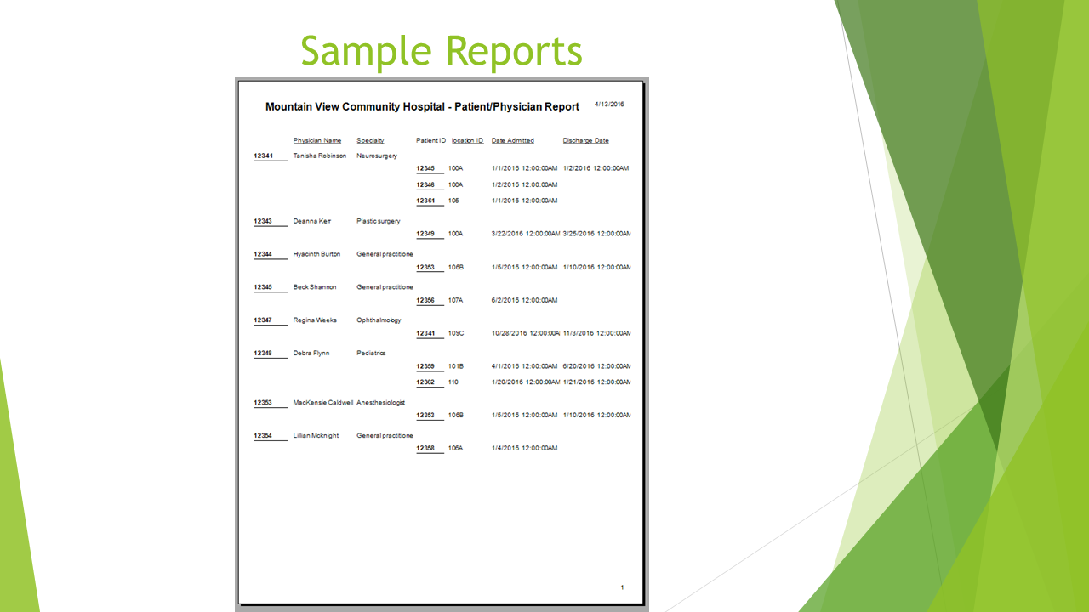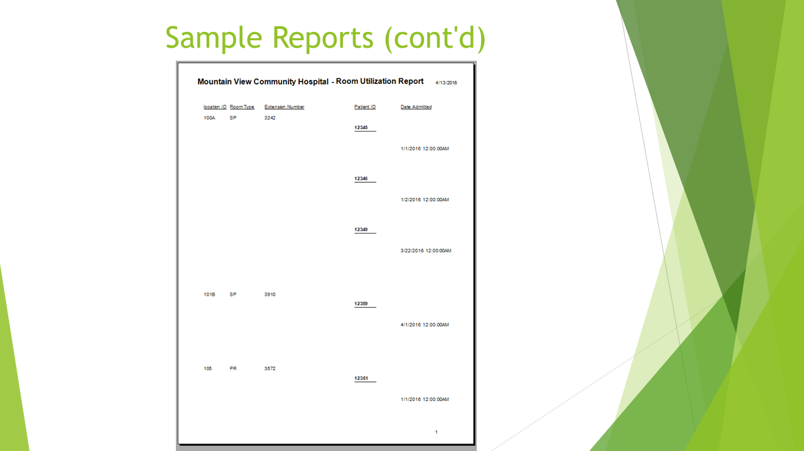

**Appendix B**

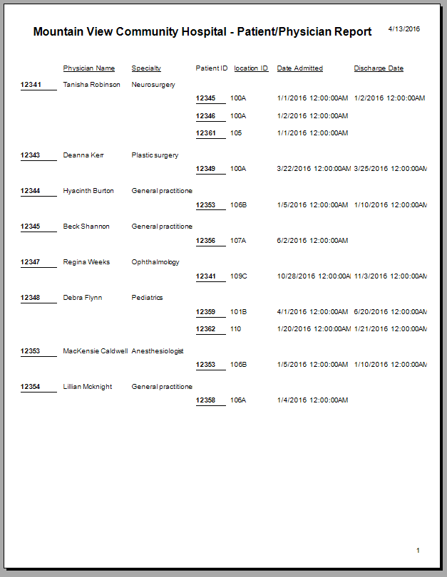

Report 1.0 (Patient/Physician Report).

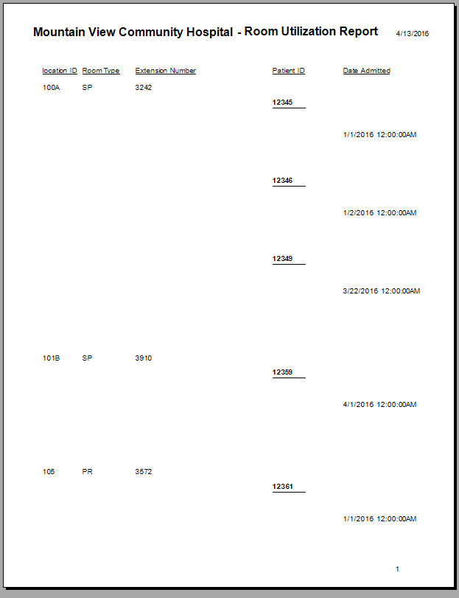

Report 2.0 (Room Utilization Report).